**USER GUIDE**

This result Analysis tool helps you to analyse the results of the students just by the uploading the pdf given by the university.

**For getting regular examination analysis of all branches:**

SGPA 🡺 Regular 🡺 Upload regular result file 🡺 Overall Analysis

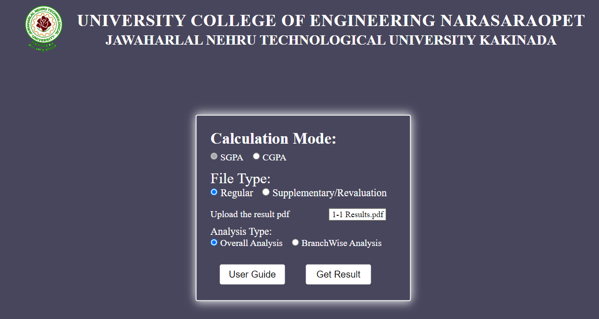

**For getting regular examination analysis of a specific branch:**

SGPA 🡺 Regular 🡺 Upload regular result file 🡺 Branch Wise Analysis 🡺 Select branch

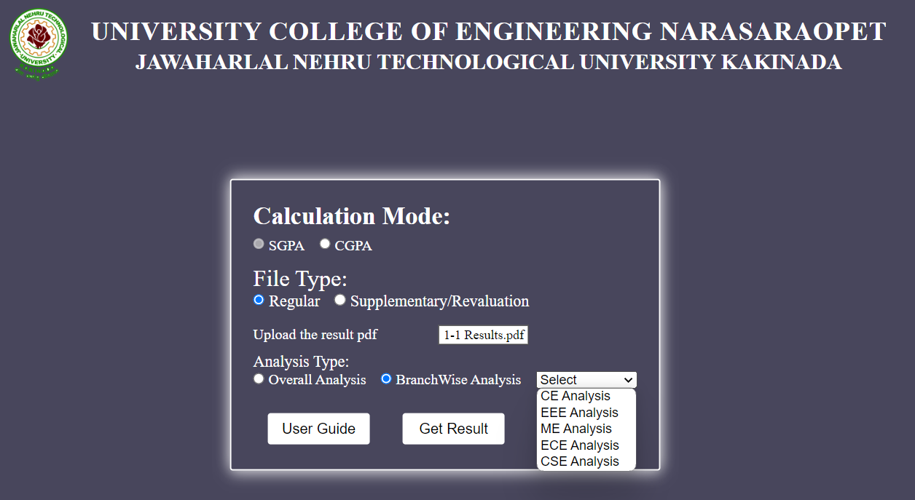

**For updating Regular result with Supplementary/ Revaluation result:**

SGPA 🡺 Supplementary/ Revaluation 🡺 Upload Supplementary/ Revaluation result file 🡺

Upload regular GPA excel

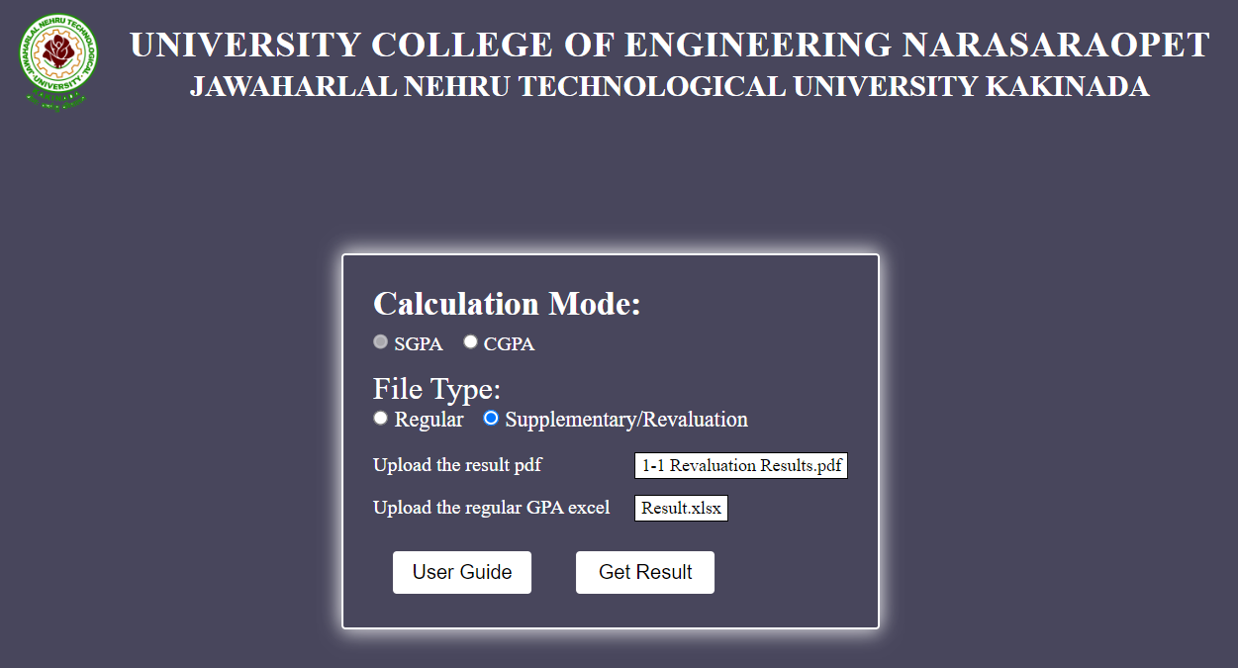

**For calculating CGPA:**

CGPA 🡺 Choose required semesters 🡺 Upload GPA Excels

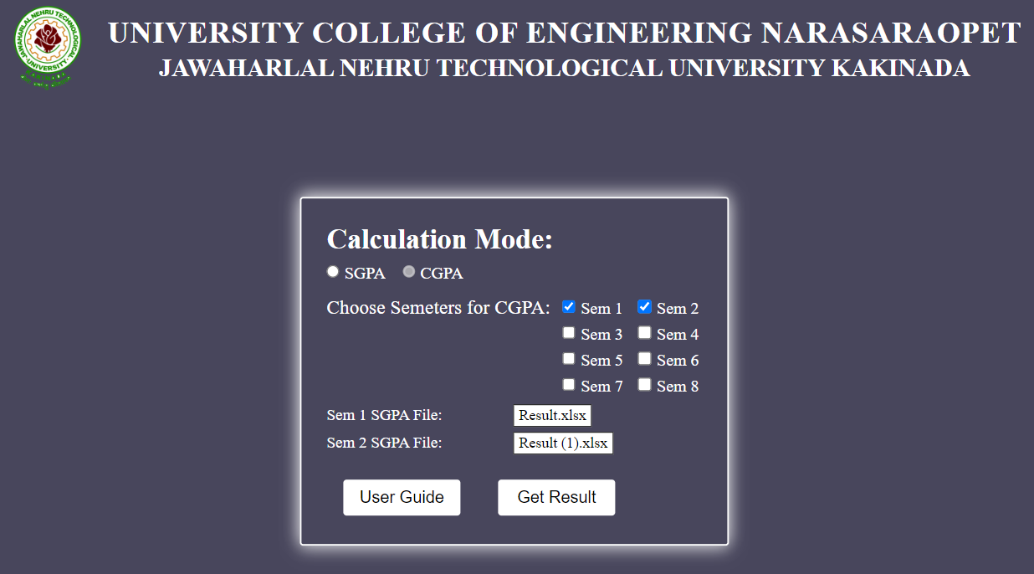

INPUT FILE FORMATS

The end line of result Pdf should be there it won’t give result if the end line is diminished. So take care